



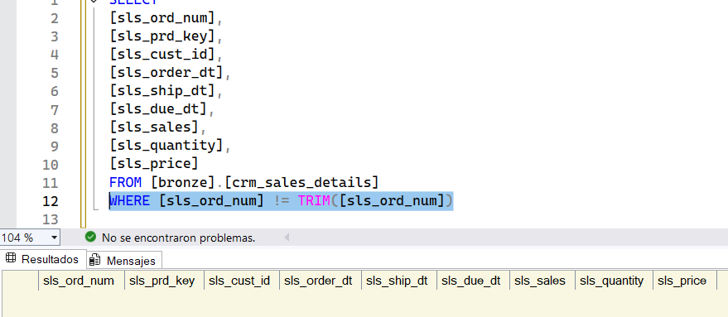

With this formula we can see that we have no unwanted spaces.

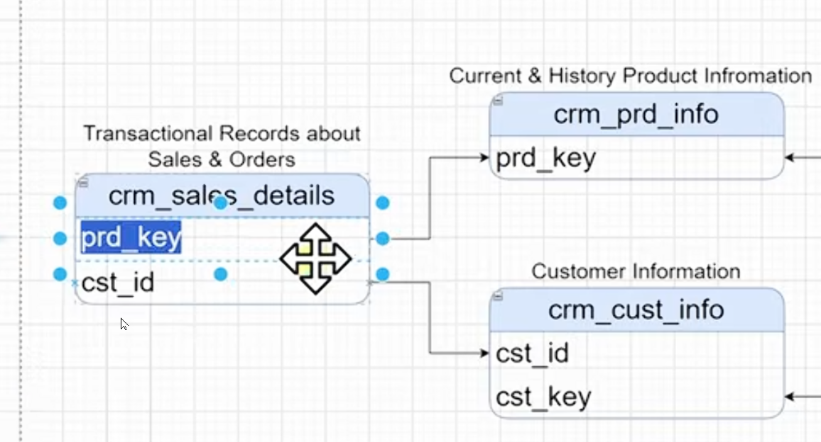

These are the connections we're going to make. That's why we need to have everything perfect.

We use the product key to connect to product information.

We're connecting the customer ID to the customer ID in customer info.

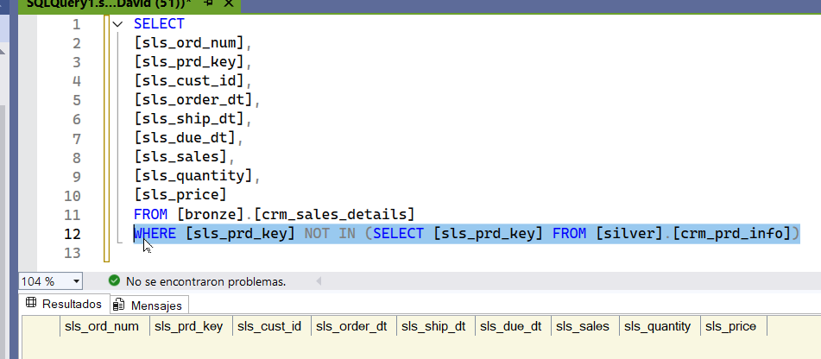

there is no problem this means that we can use the pk all the prod key from the sales details can be used and connected with the product info.

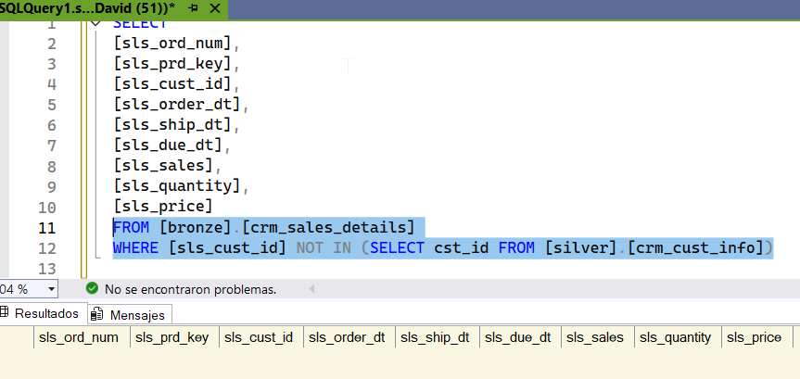

There's no problem, so we can connect to both tables without any problems. No transformations are required.

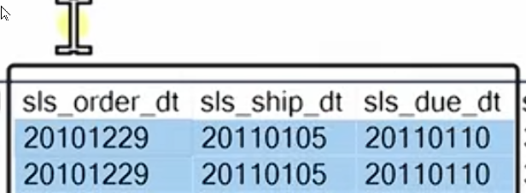

We continue with these columns. They're not dates, they're INTEGER (INT), they're numbers, and we like them that way. We need to change them from INT to DATE.



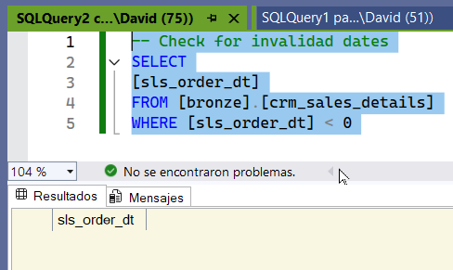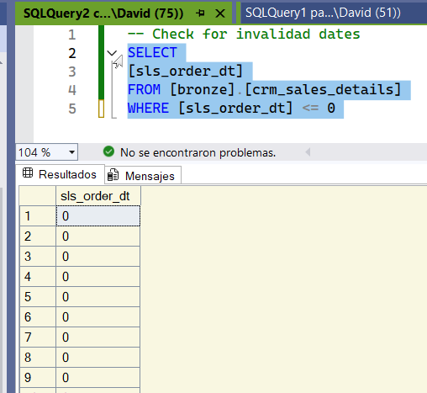

This is a problem because we have dates that say 0.

We can replace this information with null-.

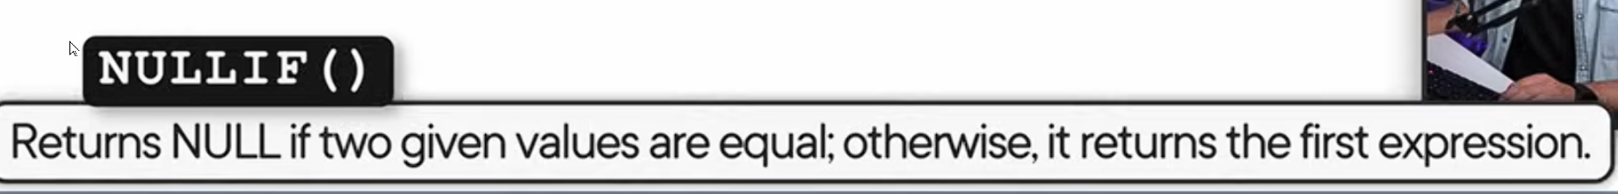

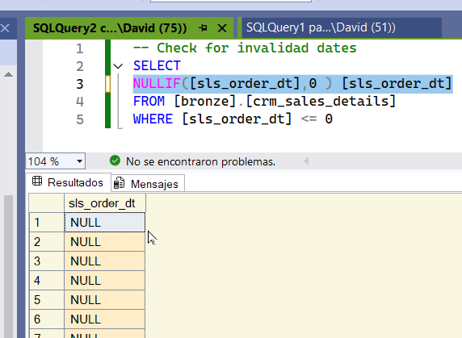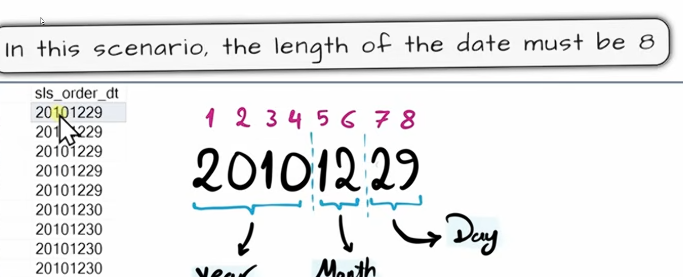

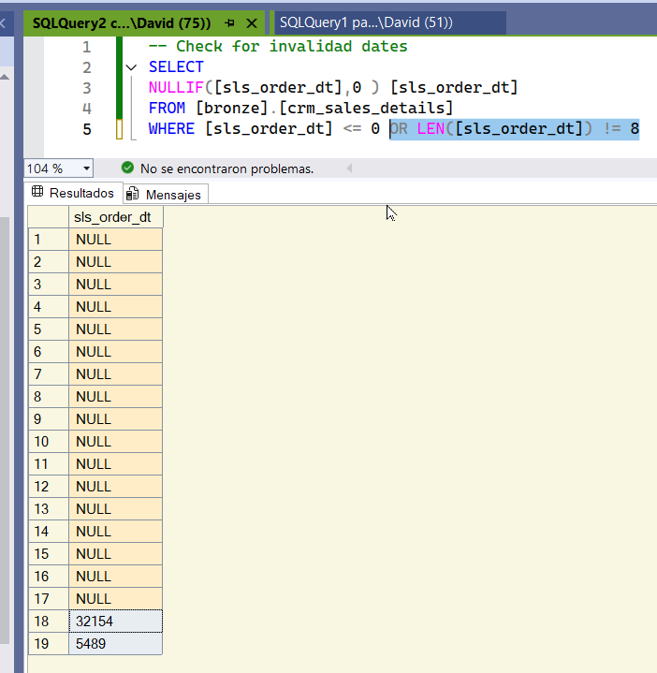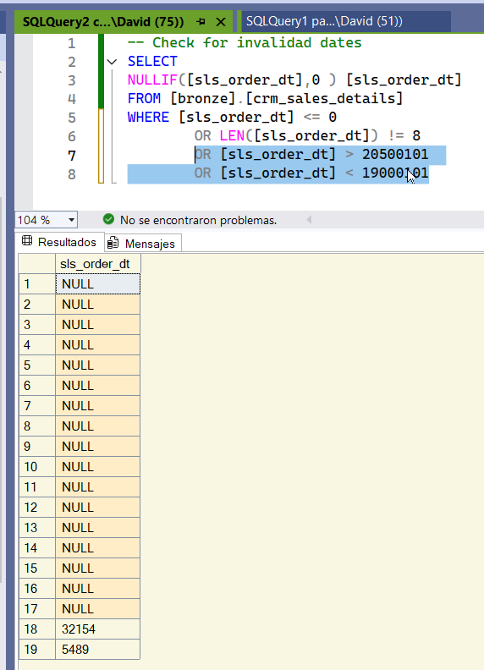

With this filter, we can see that SLAS order dts have fewer than 8 characters, so they're incorrect.

With this, we check that none are outside your business limits.

In SQL Server, we can't cast from an int to a date. You first have to convert it to a varchar, and from a varchar to a date.

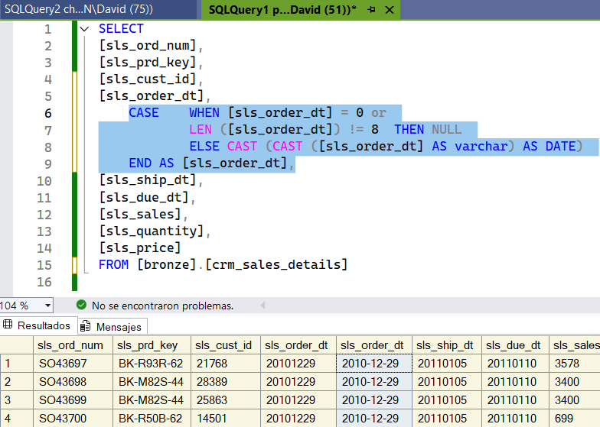

This is how we transform an INT date to a DATE. We eliminate the zeros and, if they are not 8 characters, we say NULL. We transform from INT to VARCHAR and from VARCHAR to DATE.

Now we do the same for the ship date.

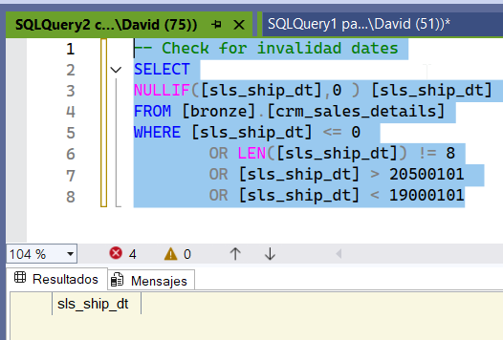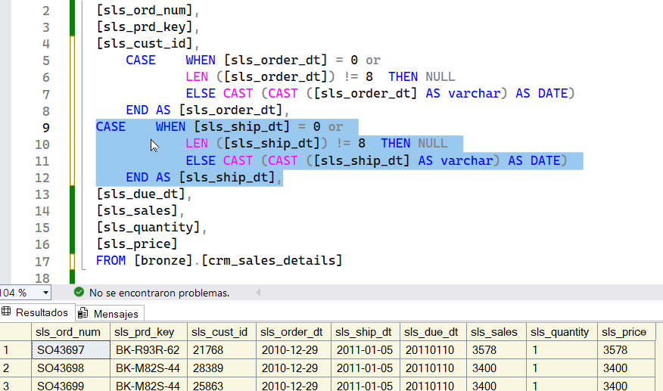

The ship date is perfect, so we don't have to make any transformations. While the ship date is fine, we changed the original formula in case the same problems arise in the future.

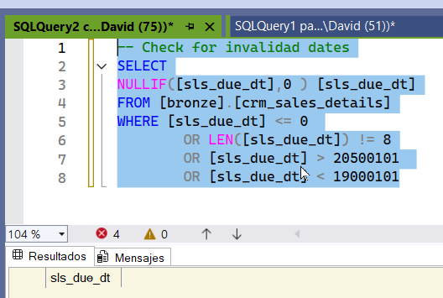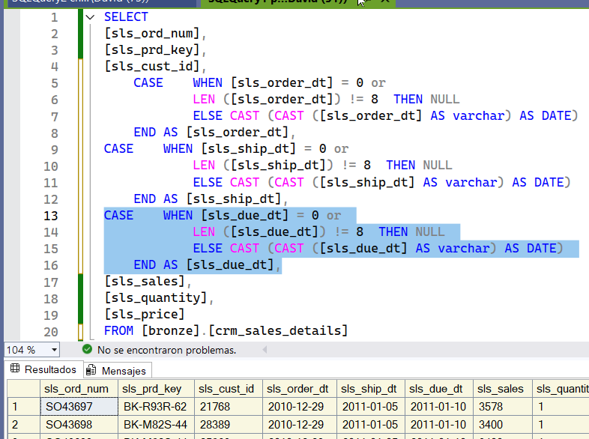

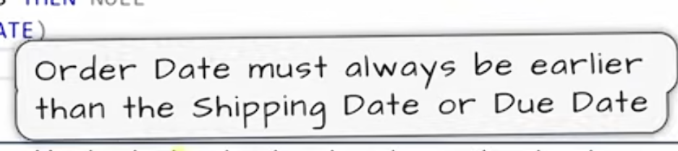

The due date is fine. We do the same for the DUE DATE. The order date must always be smaller than the ship date.

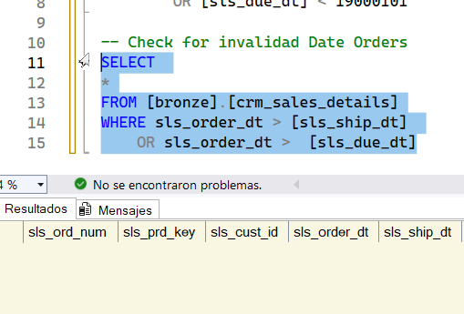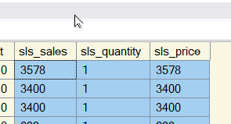

This is fine because we don't have any orders. We continue with the last three columns.

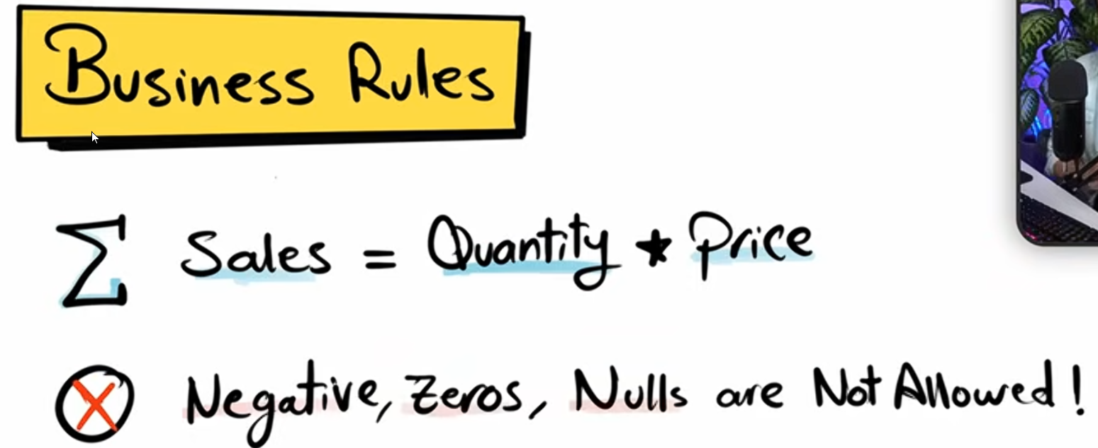

We apply a filter to see all those sales that do not meet this function.

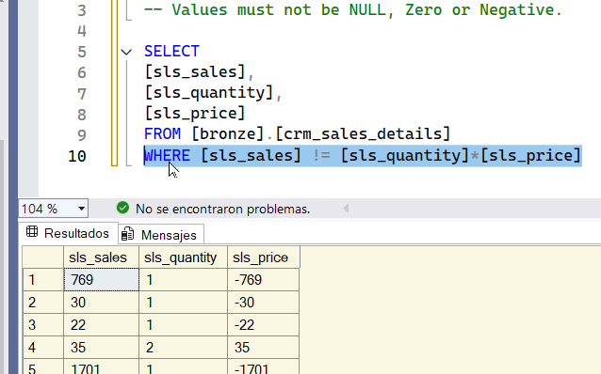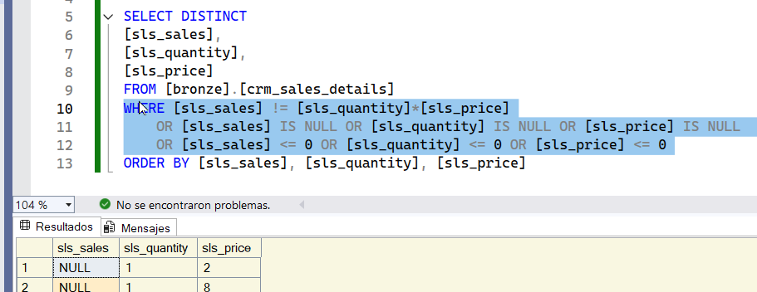

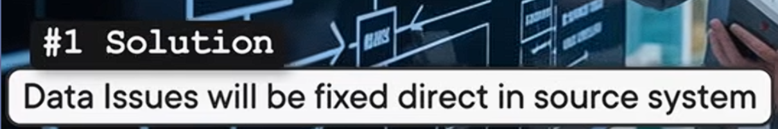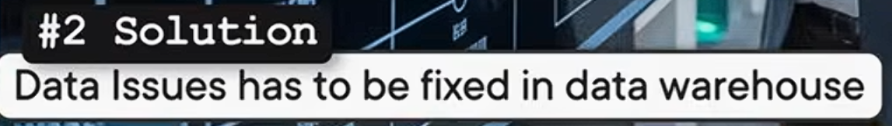

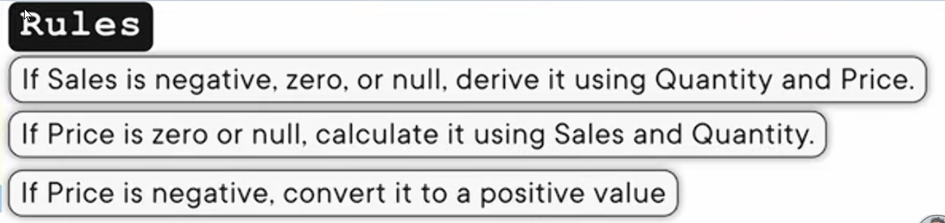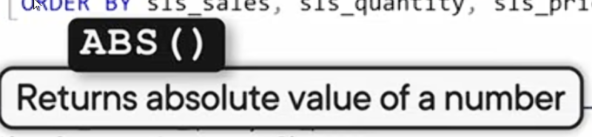

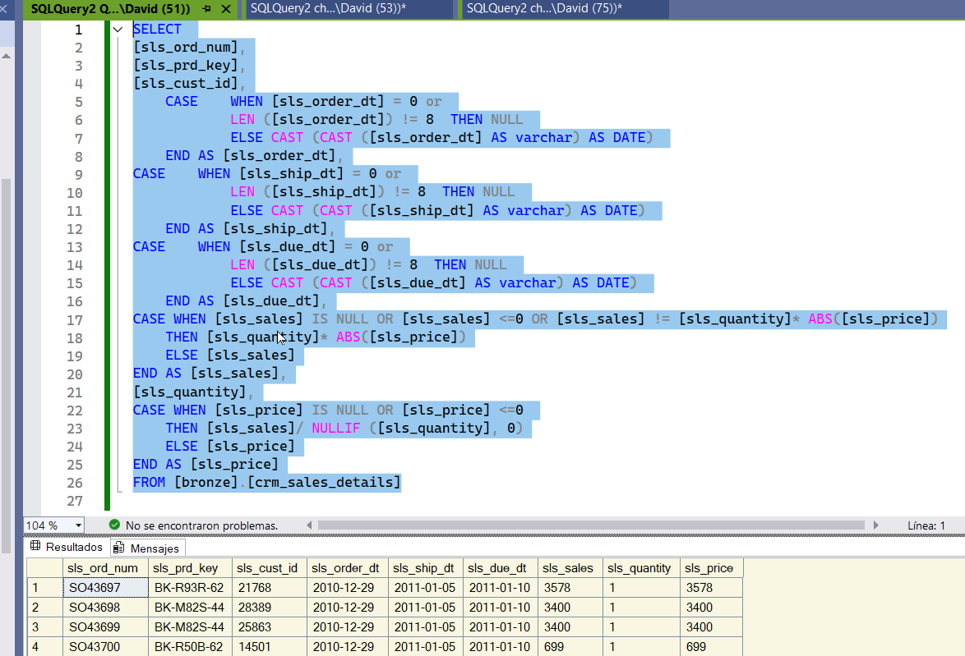

We have already cleaned the last 3 columns. Now we must do a check.

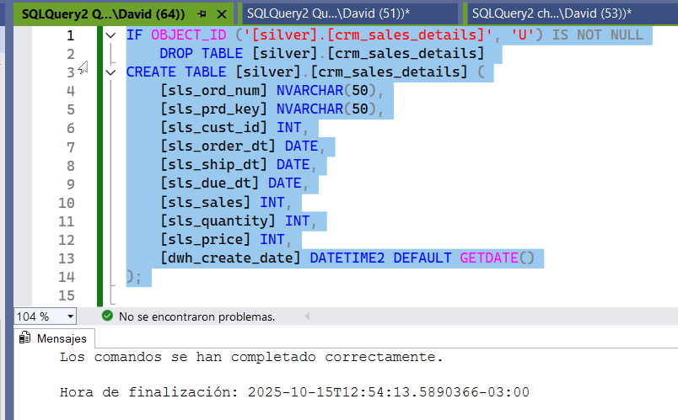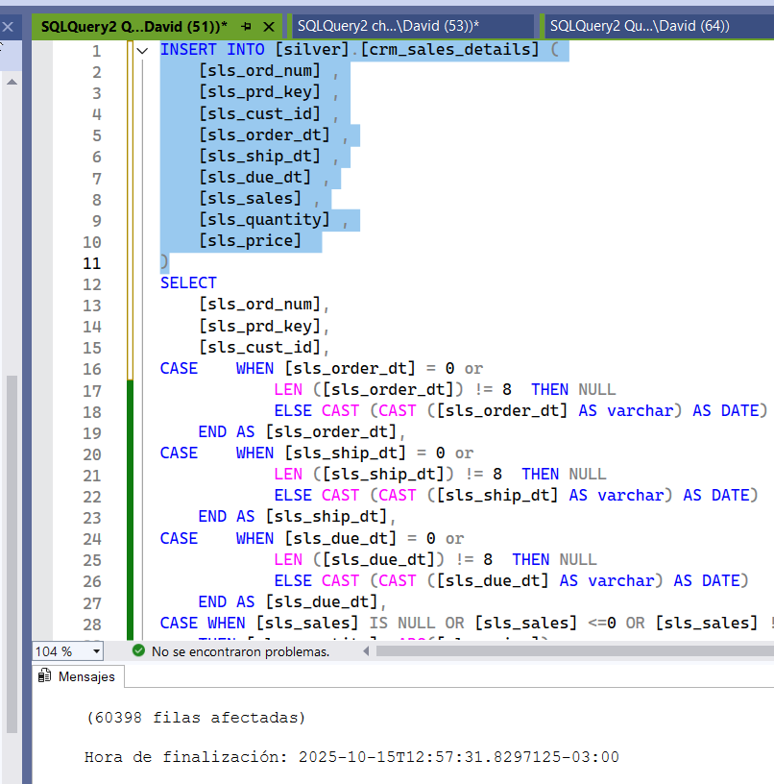

We create the table, now we insert it. Ready, we insert it into the main query.



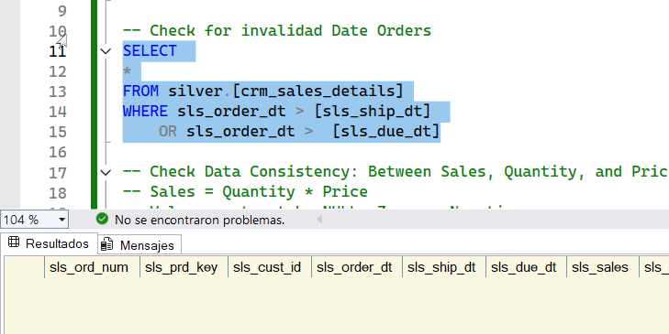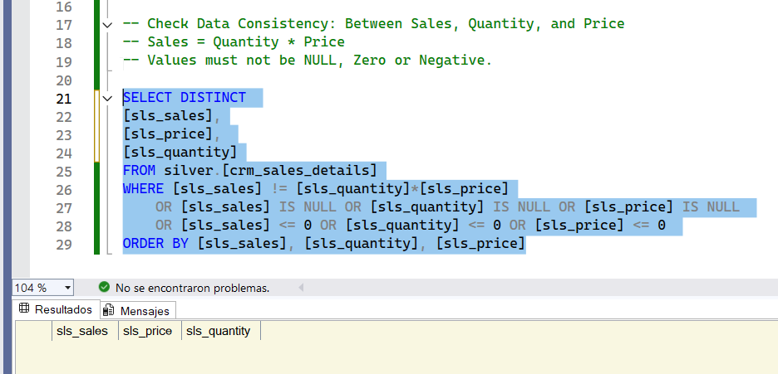

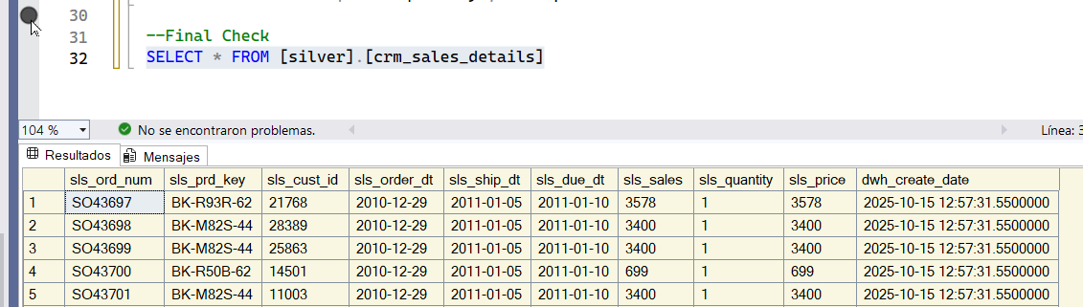

Everything is perfect!!!

Now in international format!!!

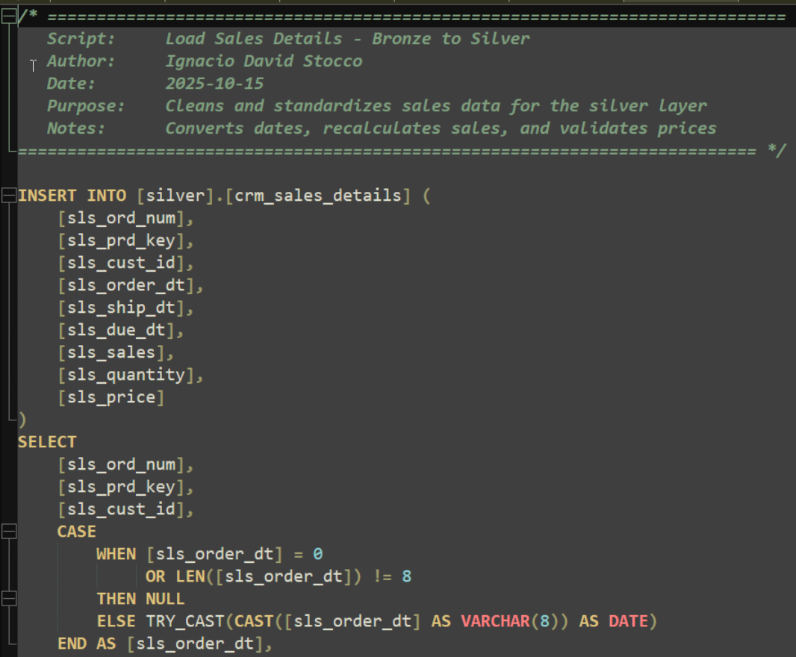

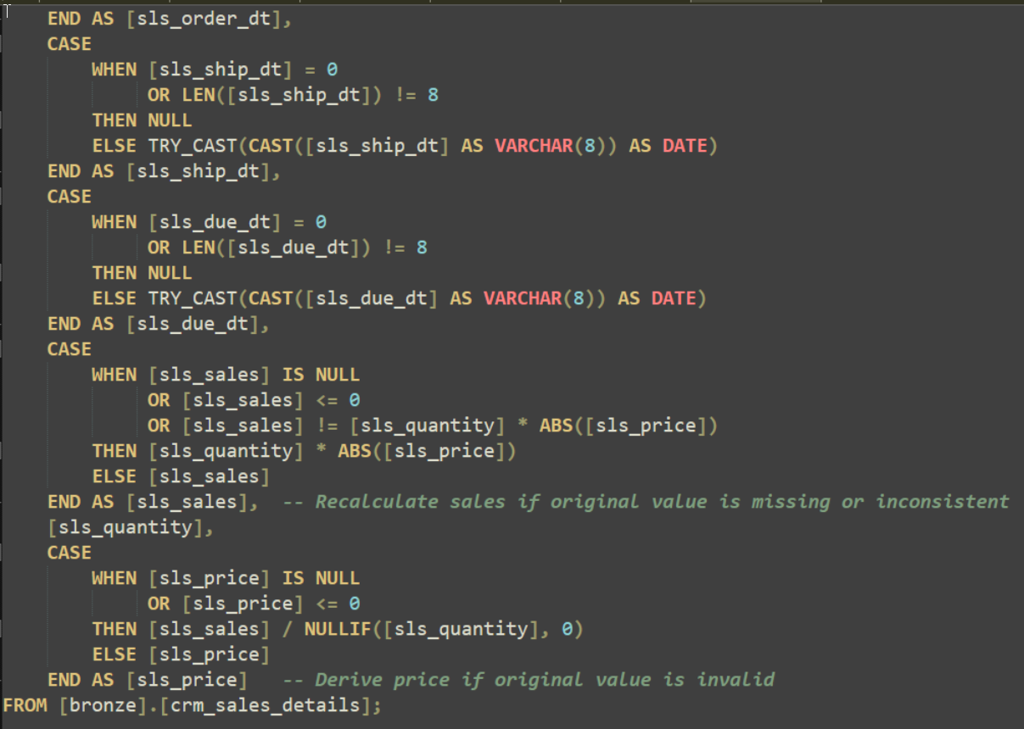

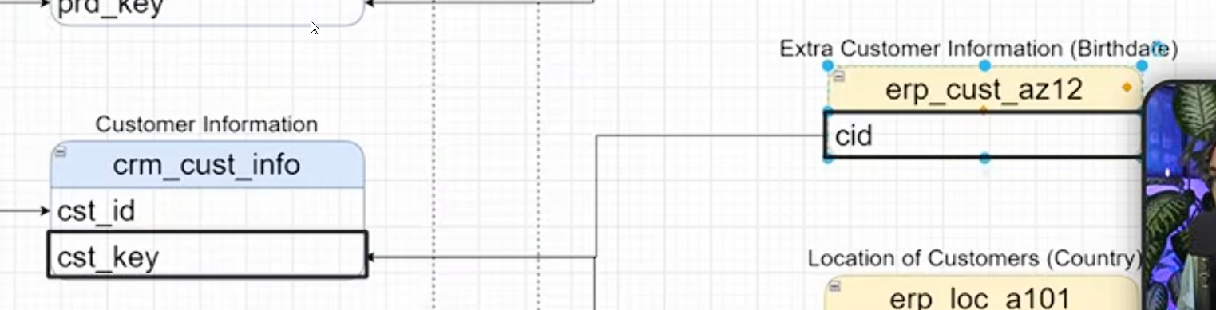

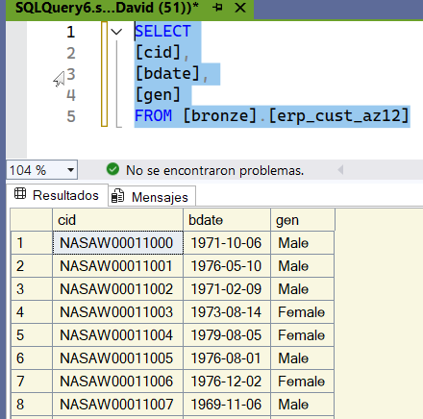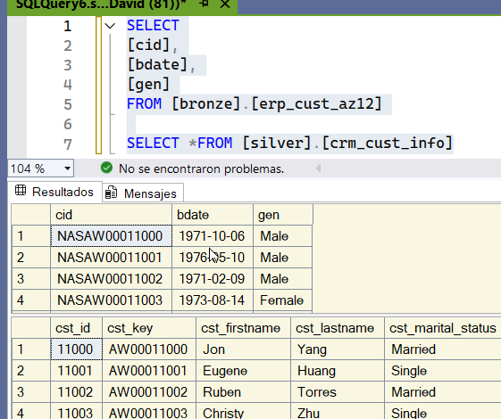

We do a layer check. There are characters we don't like.

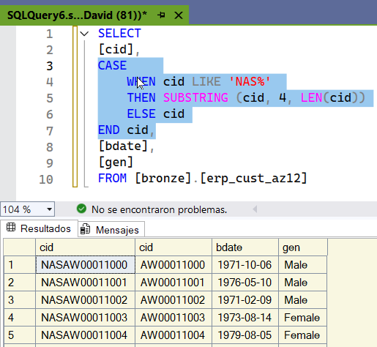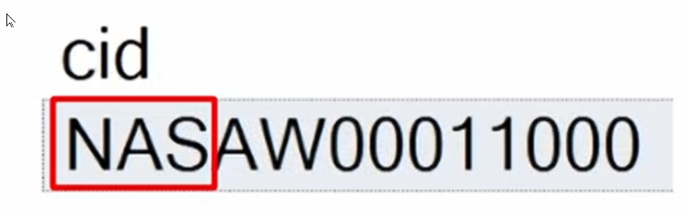

We removed NAS at the beginning. If the cid is like 3 characters. If the Id start with those 3 cgharacters then apply transformation otherwise stay as default cid. Transformation is Substring then we define the string is going to be the cid and then we have to define the position where we start cutting or extract. Then we need toi define how many chaqatders do we need to be extracted and we make it dynamic so we go with the LEN we have cid. If it is a NAS then extract from cid the position number 4 the rst of the characters.

We don't have any NAS at the start

Now we test if we can join it to the other silver table

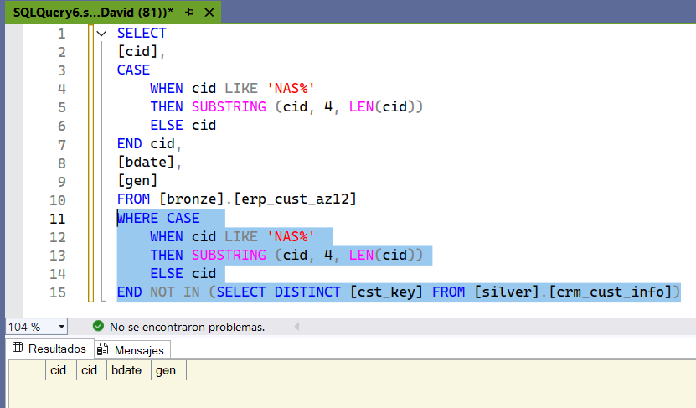

This way we check if there is any value that is not repeated in the silver table. We are unable to find any unmatching data between those 2 tables. This means our transformation is working perfectly.



Now we check the second column, bdate. We check if we have an old date.

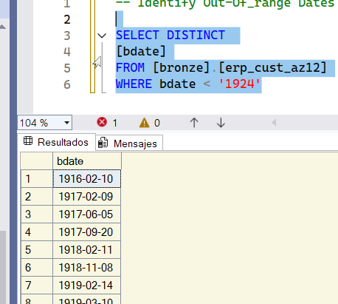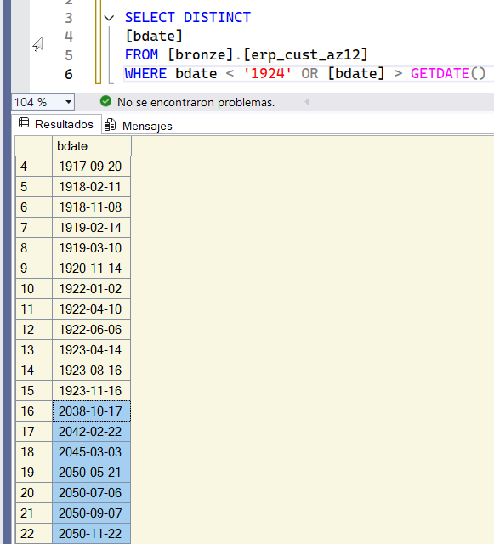

We have clients who are over 100 years old. We also have clients whose birth dates are older than the current date. This is unacceptable.

Poor data quality.

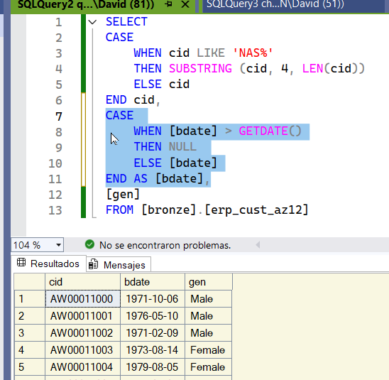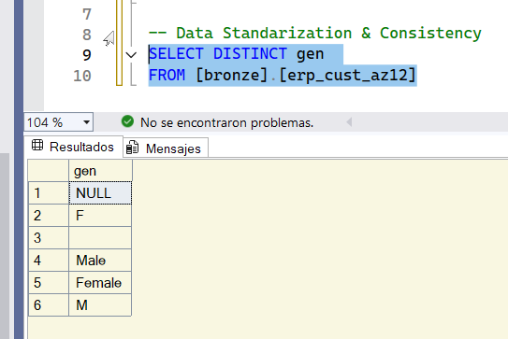

With this, we'll no longer have any clients with a date of birth in the future. We check all the possible data options. It doesn't look good. We have NULL F and an empty space. Let's clean up this information to have only three values.

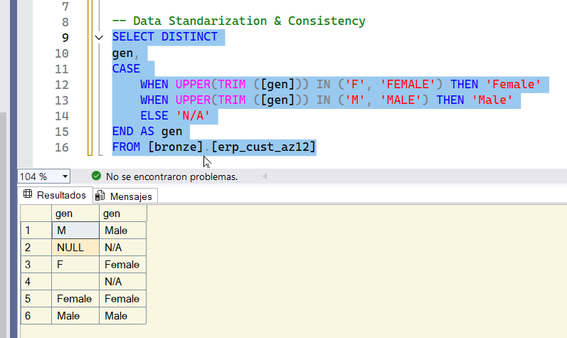 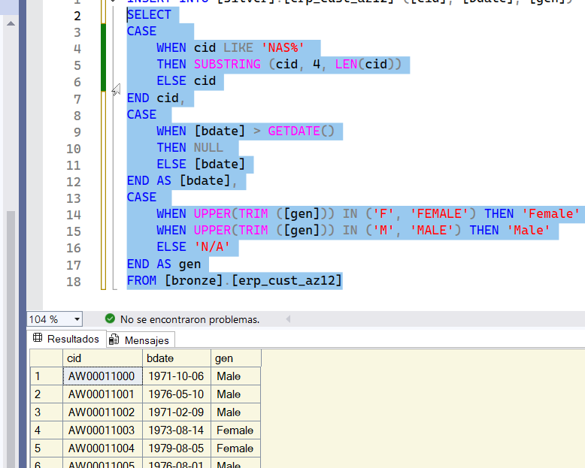

With this, we've covered all the scenarios. Everything's fine, so now let's insert it into the silver layer.

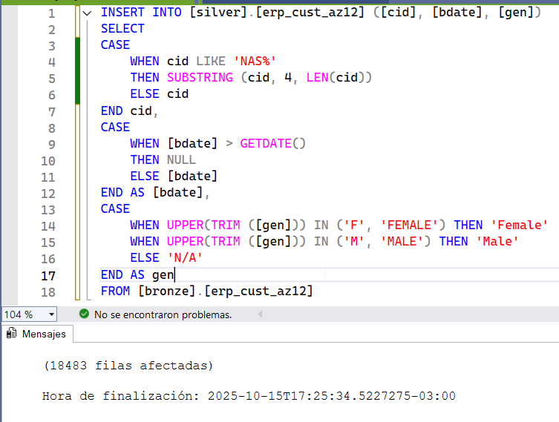



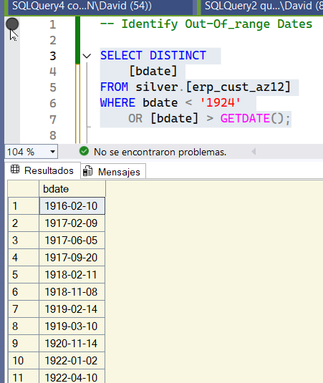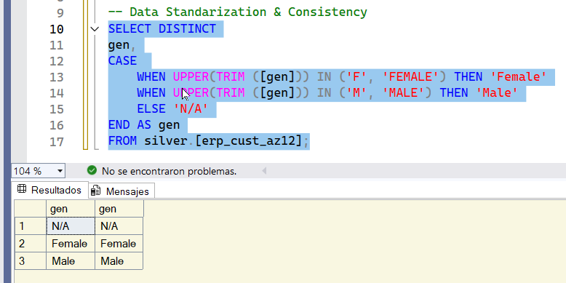

We only send those old clients. We only change those birthdays that are in the future. It's okay, we only have two values.

Final look

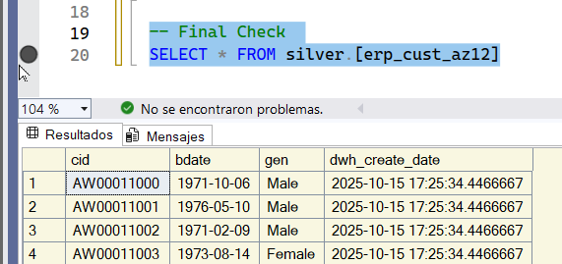

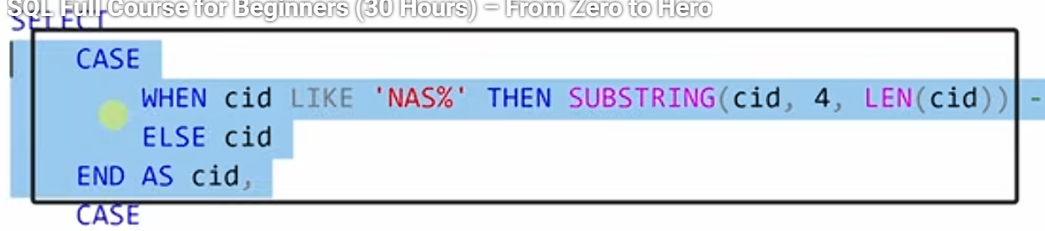

}we have hanlded invalidid values.

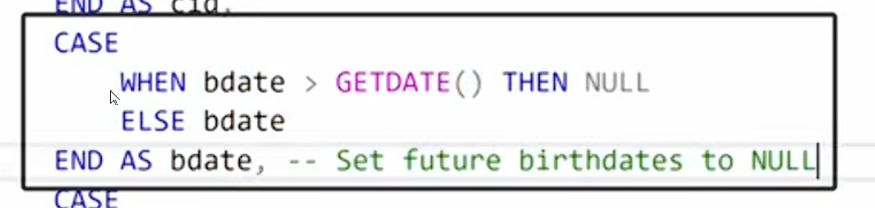

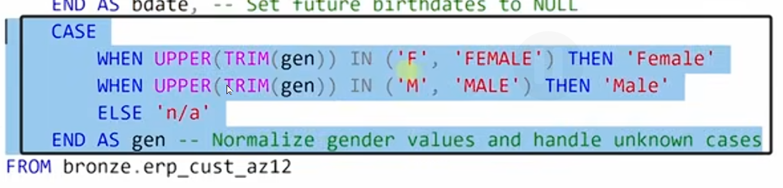

we have done data normalization.

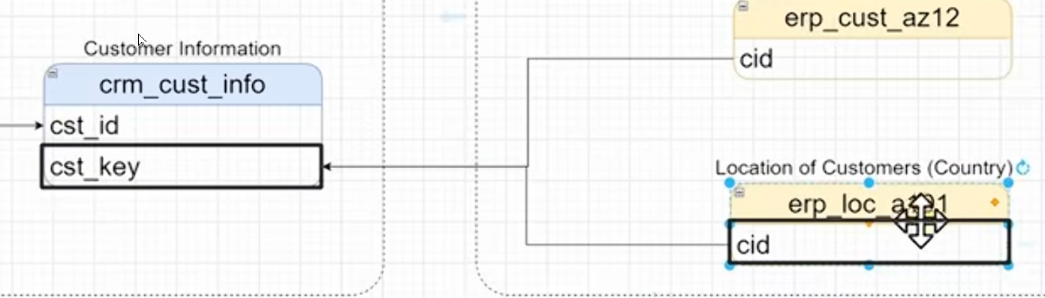

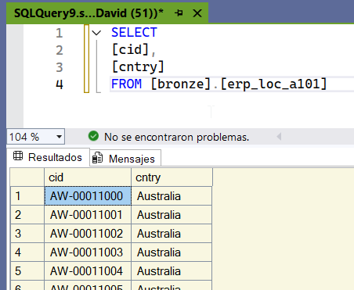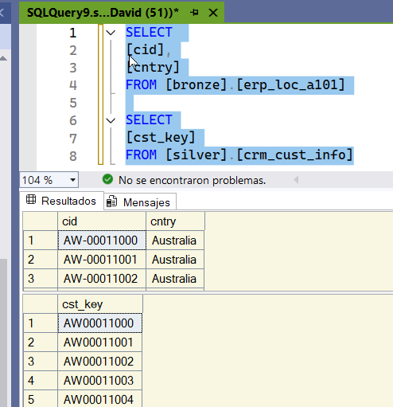

In El Cid there is a minus between the numbers and the characters. We must get rid of that minus.

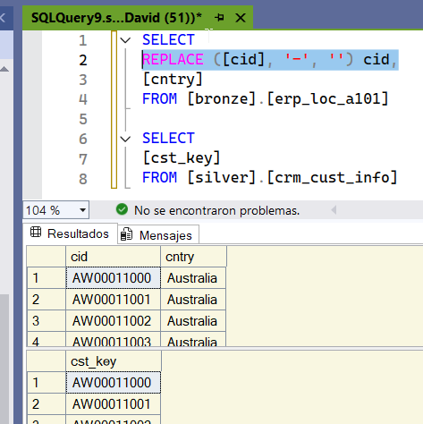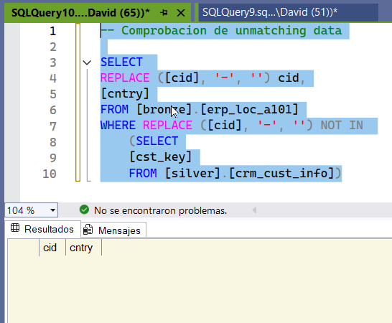

We check that all the values ​​are equal to join the tables. Our transformation is working. Now we can connect those two tables.

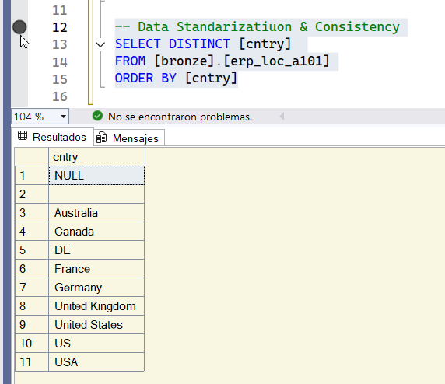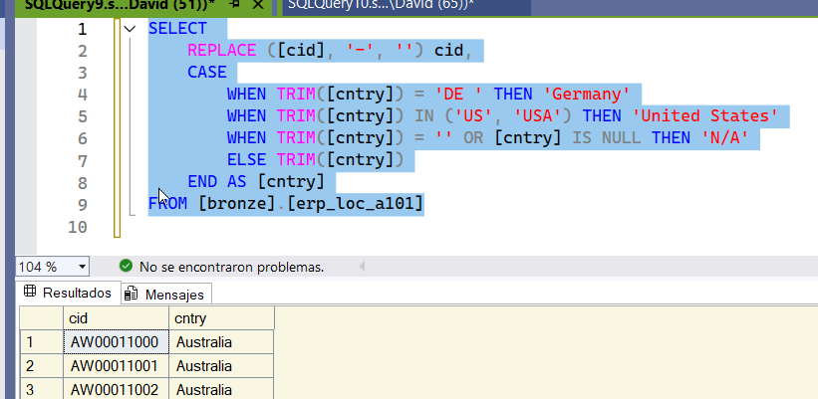

We do a quick check and see that we have null and empty values. We also have observations.

We've already made all the transformations to country.

We didn't change anything in the DDL; both are Varchar.

Now we can insert them into our table.

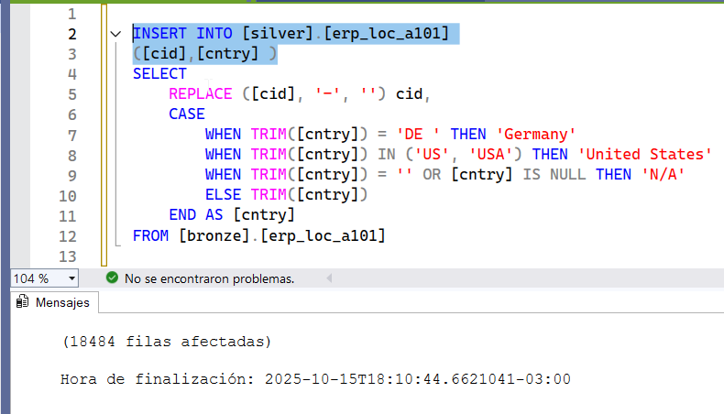



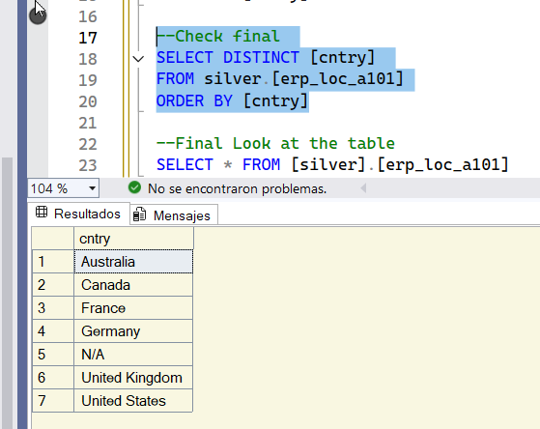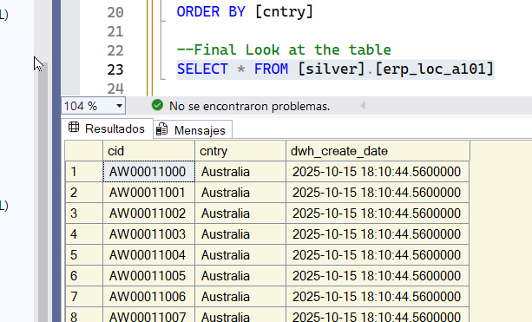

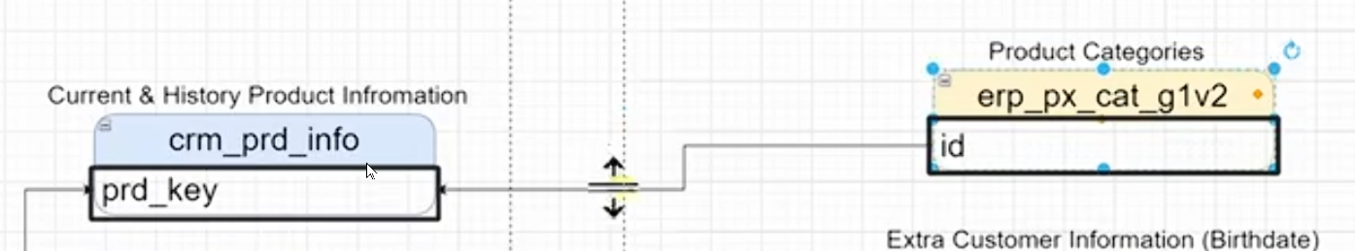

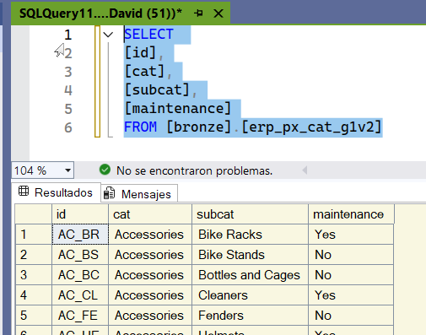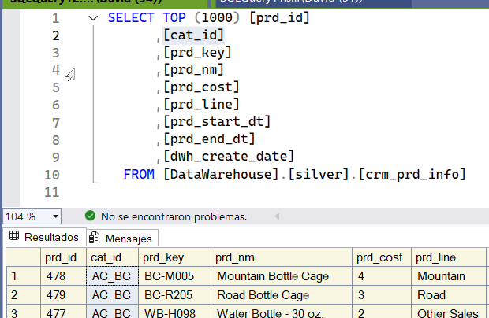

Clean up the last table.

We've created an additional table in product information called category id (cat_id), and it completely matches the id in the ERP px cat table g1v2. So there's nothing to do in the PK.

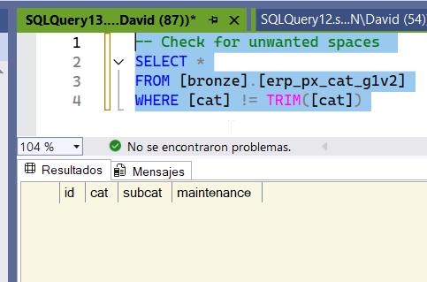 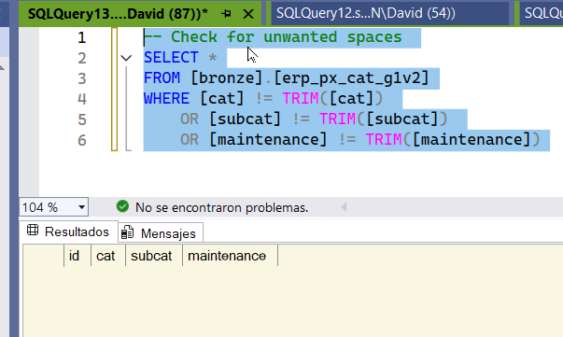

It doesn't give us any results, which means we don't have any unnecessary space.

We don't have any unnecessary space.

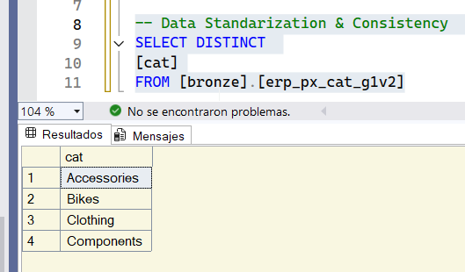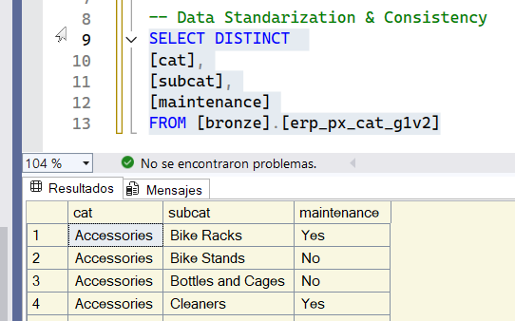

The data appears to be consistent. Everything looks perfect. The final table is pretty good, with NO issues.

No need to clean anything up.

We're loading from bronze to silver.

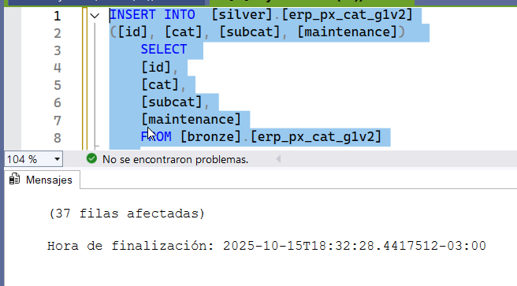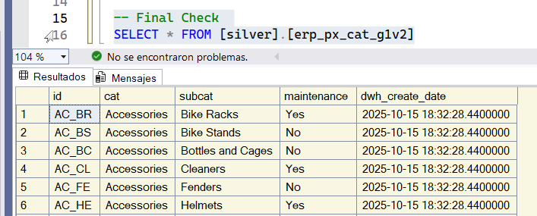

final check.

First you have to truncate the data and then do a full load.

For inserting the data we need to make sure to truncate the table. First truncate the data and then make a fully loaded

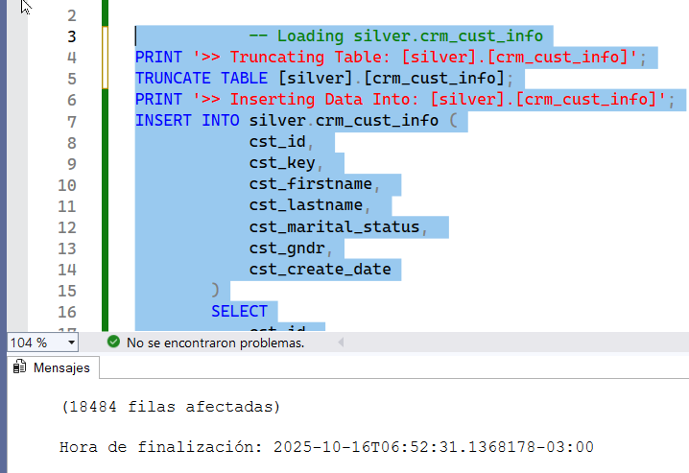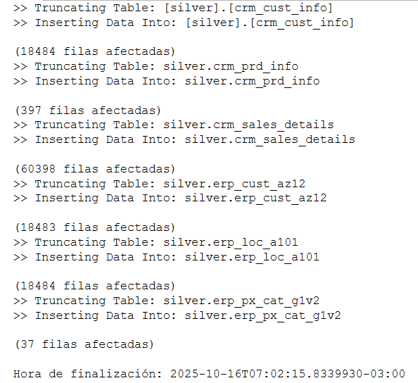

I run them all at the same time. We empty all the tables and insert the data.

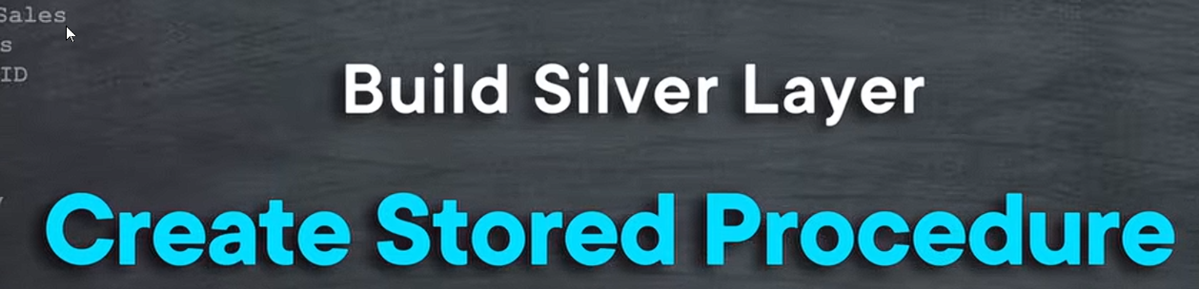



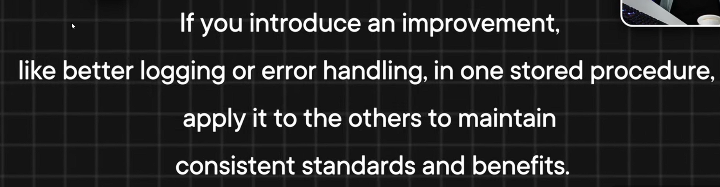

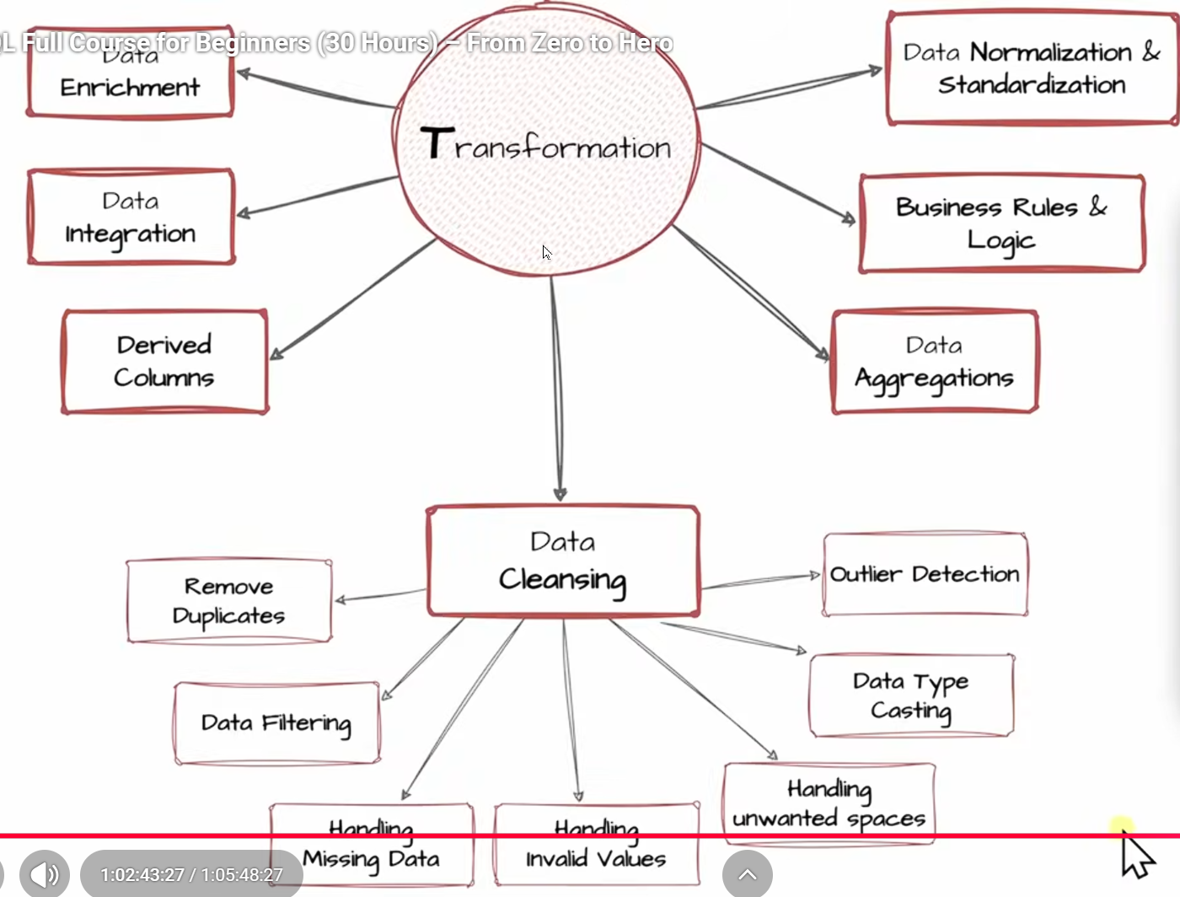



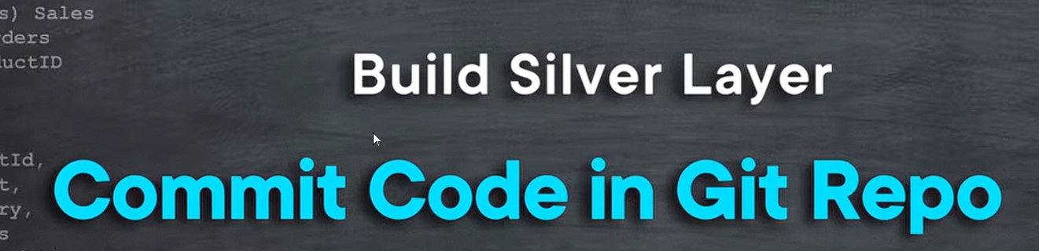

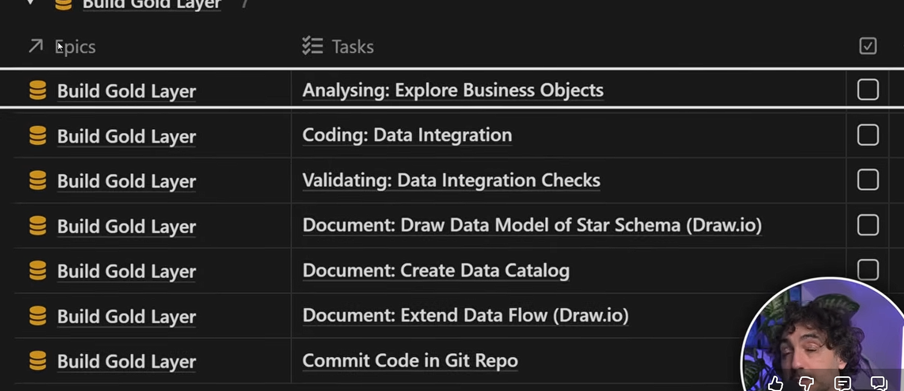

the end